**Final Report**

**Project Name:** LEARNHUB-Your Center for Skill Enhancement  
**Team ID:** LTVIP2025TMID53104

**Name:** Kuncha vyshnavi

**1. INTRODUCTION**

**1.1 Project Overview**

**LearnHub** is a comprehensive skill development and e-learning platform built using the MERN stack. It enables users to enroll in courses, access interactive learning material, and track their progress. Admins and instructors can manage course content, users, and monitor learner engagement through a dedicated dashboard.

**1.2 Purpose**

The purpose of **LearnHub** is to provide a centralized platform for individuals to enhance their skills in various domains. It focuses on delivering an intuitive and fast interface for learners and instructors, aiming to bridge the gap between knowledge seekers and educators in a digitally inclusive environment.

**2. IDEATION PHASE**

**2.1 Problem Statement**

Traditional e-learning platforms are often cluttered, expensive, or lack real-time personalization. Learners struggle with motivation, while instructors lack tools to monitor progress and engagement. **LearnHub** addresses these issues by offering a responsive, customizable, and user-focused learning environment.

**2.2 Empathy Map Canvas**

**Stakeholders considered:**

* **Learners**: Seek flexible, interactive, and affordable learning options.
* **Instructors**: Need efficient content upload and student analytics tools.
* **Admins**: Require moderation controls and analytics access.

**Concerns Addressed:**

* Personalized course dashboard
* Secure registration and access
* Role-based functionality (Student, Instructor, Admin)
* Mobile-accessible learning

**2.3 Brainstorming**

Key features considered:

* Course progress tracking
* Role-based dashboard
* Embedded video lectures, PDFs, quizzes
* Secure login
* Responsive across devices

**3. REQUIREMENT ANALYSIS**

**3.1 Learner Journey Map**

1. Register/Login
2. Browse available courses
3. Enroll and access content
4. Complete quizzes/assignments
5. Track progress and earn certificates

**3.2 Solution Requirements**

**Functional:**

* Role-based login system (JWT)
* Course listing, enrollment, and progress tracking
* Instructor and Admin dashboards
* Quiz and assignment uploads
* Certificate generation

**Non-Functional:**

* Fast load time (<2s)
* Secure API communication
* Responsive design
* Scalable up to 5000+ users

**3.3 Data Flow Diagram**

User Action → Frontend → API Call → Database → Response → Updated UI

**3.4 Technology Stack**

* **Frontend**: React.js
* **Backend**: Node.js + Express.js
* **Database**: MongoDB Atlas
* **Authentication**: JWT

**4. PROJECT DESIGN**

**4.1 Problem-Solution Fit**

**LearnHub** ensures learners have seamless access to educational content while instructors maintain control of their materials. The platform promotes self-paced learning with a modern UI.

**4.2 Proposed Solution**

A modular, scalable web application with:

* Learner panel for course browsing and participation
* Instructor panel for content upload and student monitoring
* Admin panel for platform-wide analytics and moderation

**4.3 Solution Architecture**

* **Frontend (React)**: UI, routing
* **Backend (Node/Express)**: API logic
* **Database (MongoDB)**: Users, courses, assignments, progress data

**5. PROJECT PLANNING & SCHEDULING**

**5.1 Timeline**

| **Week** | **Task** |
| --- | --- |
| 1–2 | Requirement Analysis |
| 3–4 | UI Design & Backend Setup |
| 5–6 | Integration of Features |
| 7–8 | Testing & Final Documentation |

**Team Roles**

| **Member** | **Role** | **Contribution** |
| --- | --- | --- |
| A | Frontend Developer | Course list, learner UI, responsiveness |
| B | Backend Developer | APIs, DB setup, authentication |
| C | Tester | Functional and UI testing |
| D | Project Lead | Coordination, integration, documentation |

**6. FUNCTIONAL AND PERFORMANCE TESTING**

**6.1 Performance Results**

* Registration/login: 100% success
* Course enrollment: <2s latency
* Concurrent user handling: 50
* Uptime during test: 99.8%

**6.2 Sample Test Cases**

| **ID** | **Scenario** | **Steps** | **Expected Result** |
| --- | --- | --- | --- |
| TC-001 | User Registration | Fill signup form | Account created |
| TC-002 | Course Enrollment | Click enroll button | Access granted |
| TC-003 | Quiz Submission | Attempt and submit quiz | Score displayed |

1. **RESULTS**

**Landing page:**

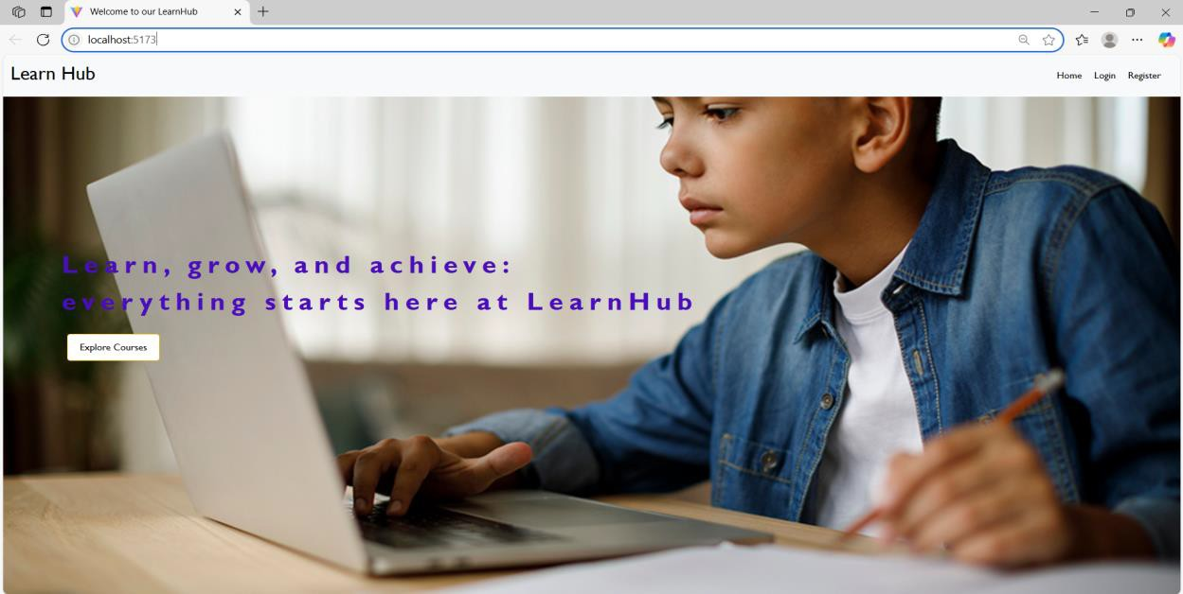

Register page:

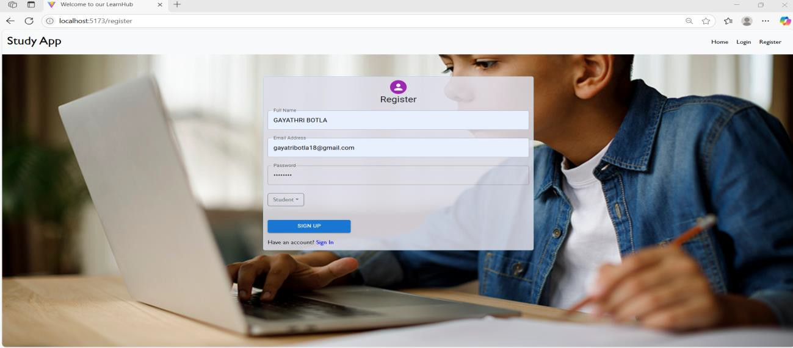**login page:**

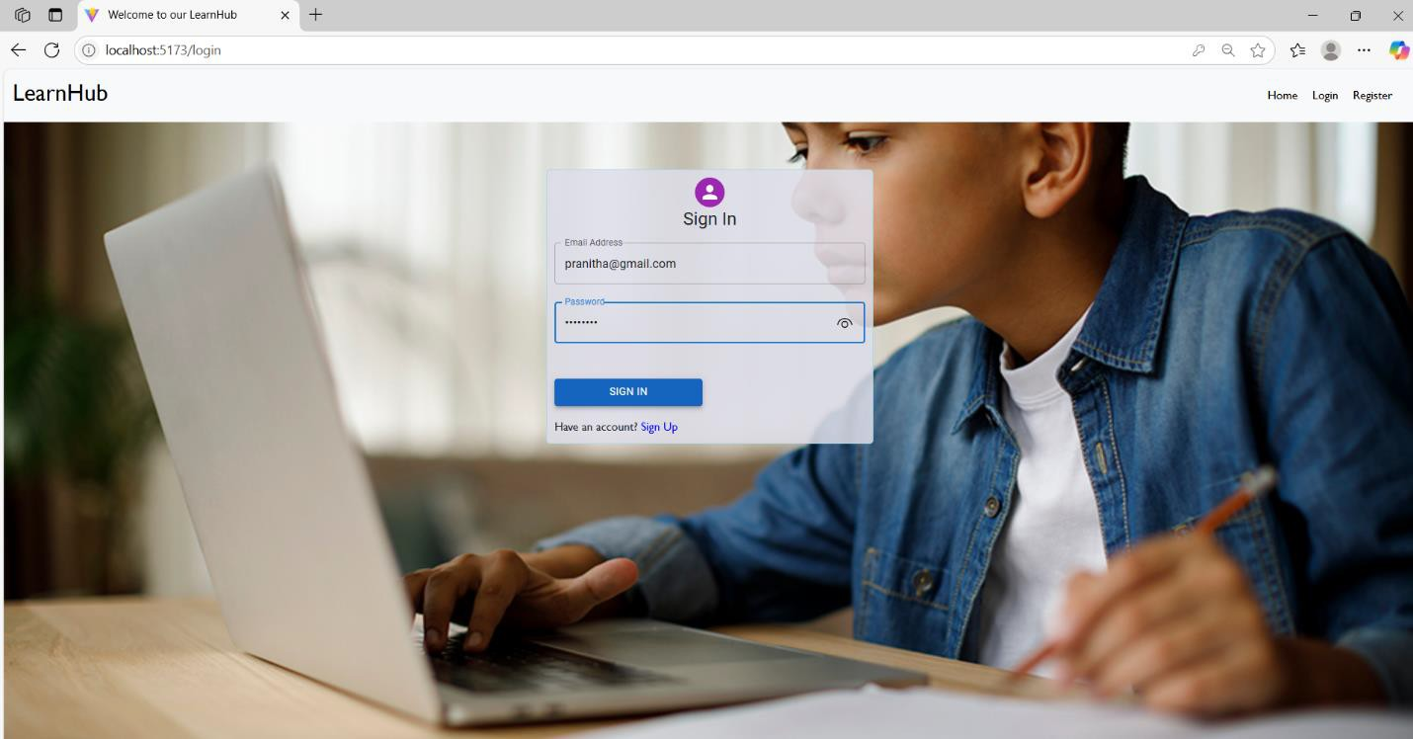

**Admin Dashboard:**

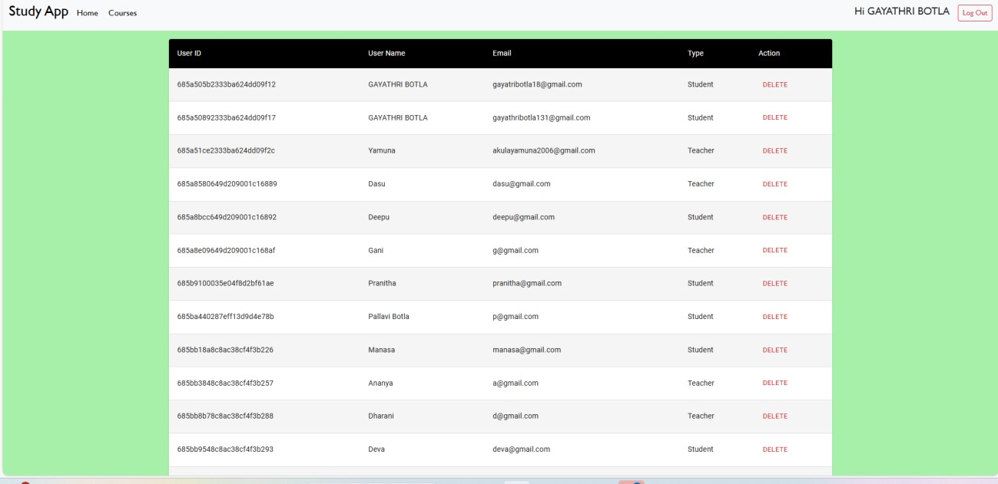

**Teacher Dashboard:**

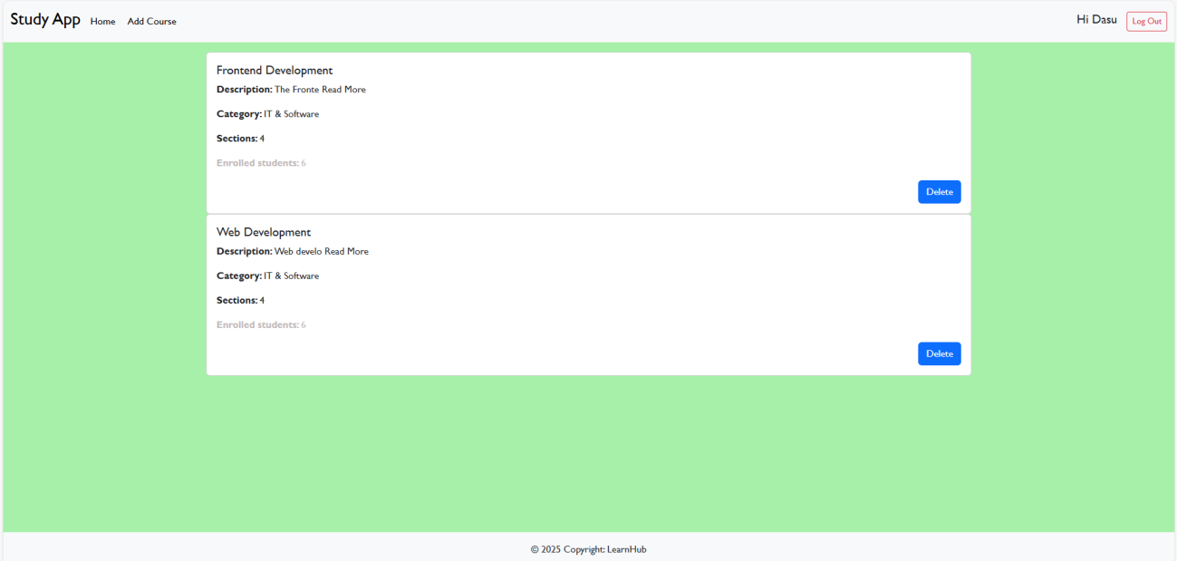

**Student Dashboard:**

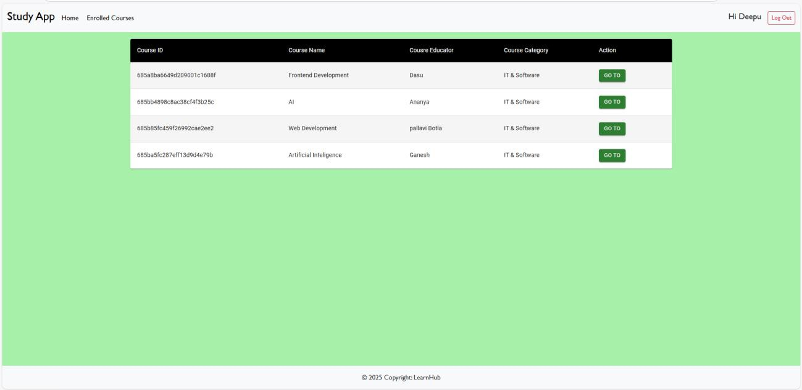

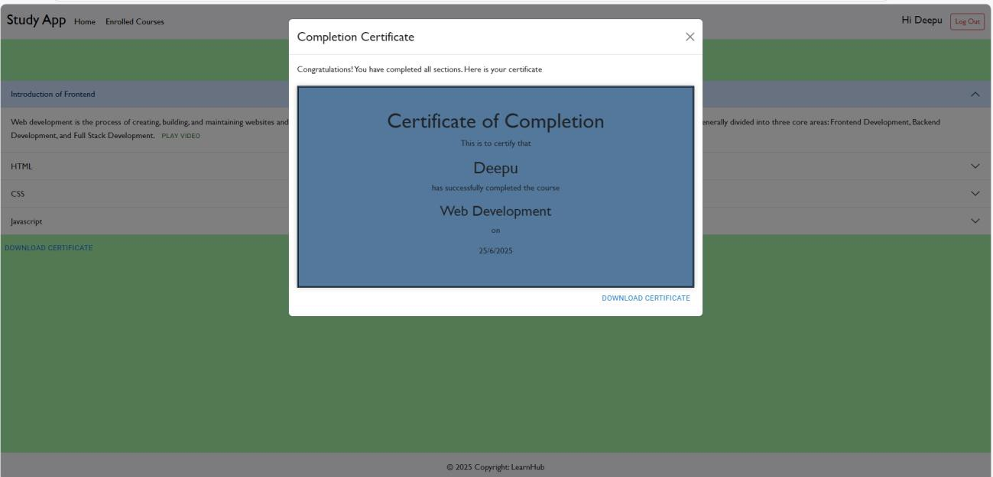

**Usability Feedback**:  
85% of test users completed a full course journey without assistance.

**8. ADVANTAGES & DISADVANTAGES**

**Advantages:**

* Personalized learner journey
* Intuitive course progress tracking
* Secure, scalable architecture
* Cross-device support

**Disadvantages:**

* No mobile app (in development)
* Limited gamification (future upgrade)

**9. CONCLUSION**

**LearnHub** delivers a clean, efficient learning experience for both students and educators. With built-in tracking, role-based access, and future expandability, it stands as a strong foundation for scalable digital education.

**10. FUTURE SCOPE**

* React Native mobile app
* Gamified learning paths
* AI tutor chatbot
* Peer discussion forums
* Advanced analytics dashboard

**11. APPENDIX**

* **GitHub Repository:** **https://github.com/kunchavyshnavi/LearnHub-Your-Center-for-Skill-Enhancement-.git**
* **VIDEO CLIP:** **https://drive.google.com/file/d/136Tr2T1Oz1eDne20QyGKvV7E-5mhgzxZ/view?usp=drivesdk**